**06-08-2024**

**Selection sort:**

public class SelectionSort {

public static void main(String[] args) {

int[] arr = {64, 25, 12, 22, 11};

System.out.println("Original array:");

printArray(arr);

selectionSort(arr);

System.out.println("Sorted array:");

printArray(arr);

}

public static void selectionSort(int[] arr) {

int n = arr.length;

for (int i = 0; i < n - 1; i++) {

int minIndex = i;

for (int j = i + 1; j < n; j++) {

if (arr[j] < arr[minIndex]) {

minIndex = j;

}

}

int temp = arr[minIndex];

arr[minIndex] = arr[i];

arr[i] = temp;

}

}

public static void printArray(int[] arr) {

for (int i = 0; i < arr.length; i++) {

System.out.print(arr[i] + " ");

}

System.out.println();

}

}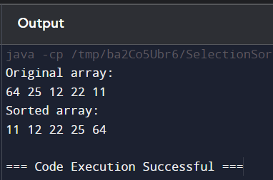

**Bubble sort**

public class BubbleSort {

public static void main(String[] args) {

int[] arr = {64, 25, 12, 22, 11};

System.out.println("Original array:");

printArray(arr);

bubbleSort(arr);

System.out.println("Sorted array:");

printArray(arr);

}

public static void bubbleSort(int[] arr) {

int n = arr.length;

for (int i = 0; i < n - 1; i++) {

for (int j = 0; j < n - i - 1; j++) {

if (arr[j] > arr[j + 1]) {

int temp = arr[j];

arr[j] = arr[j + 1];

arr[j + 1] = temp;

}

}

}

}

public static void printArray(int[] arr) {

for (int i = 0; i < arr.length; i++) {

System.out.print(arr[i] + " ");

}

System.out.println();

}

}

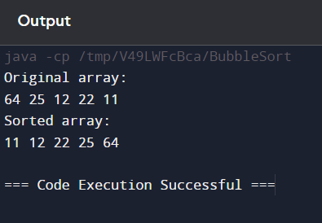

**Linear search**

public class LinearSearch {

public static void main(String[] args) {

int[] arr = {64, 25, 12, 22, 11};

int target = 22;

System.out.println("Array:");

printArray(arr);

int result = linearSearch(arr, target);

if (result == -1) {

System.out.println("Element not found");

} else {

System.out.println("Element found at index " + result);

}

}

public static int linearSearch(int[] arr, int target) {

for (int i = 0; i < arr.length; i++) {

if (arr[i] == target) {

return i;

}

}

return -1;

}

public static void printArray(int[] arr) {

for (int i = 0; i < arr.length; i++) {

System.out.print(arr[i] + " ");

}

System.out.println();

}

}

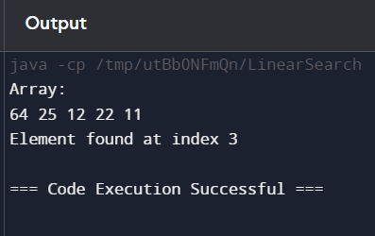

**Binary search**

public class BinarySearch {

public static void main(String[] args) {

int[] arr = {11, 12, 22, 25, 64};

int target = 22;

System.out.println("Array:");

printArray(arr);

int result = binarySearch(arr, target);

if (result == -1) {

System.out.println("Element not found");

} else {

System.out.println("Element found at index " + result);

}

}

public static int binarySearch(int[] arr, int target) {

int left = 0;

int right = arr.length - 1;

while (left <= right) {

int mid = left + (right - left) / 2;

if (arr[mid] == target) {

return mid;

} else if (arr[mid] < target) {

left = mid + 1;

} else {

right = mid - 1;

}

}

return -1;

}

public static void printArray(int[] arr) {

for (int i = 0; i < arr.length; i++) {

System.out.print(arr[i] + " ");

}

System.out.println();

}

}

